PRESS KIT

Creation of the first impact fund dedicated to education in Africa
January 2019

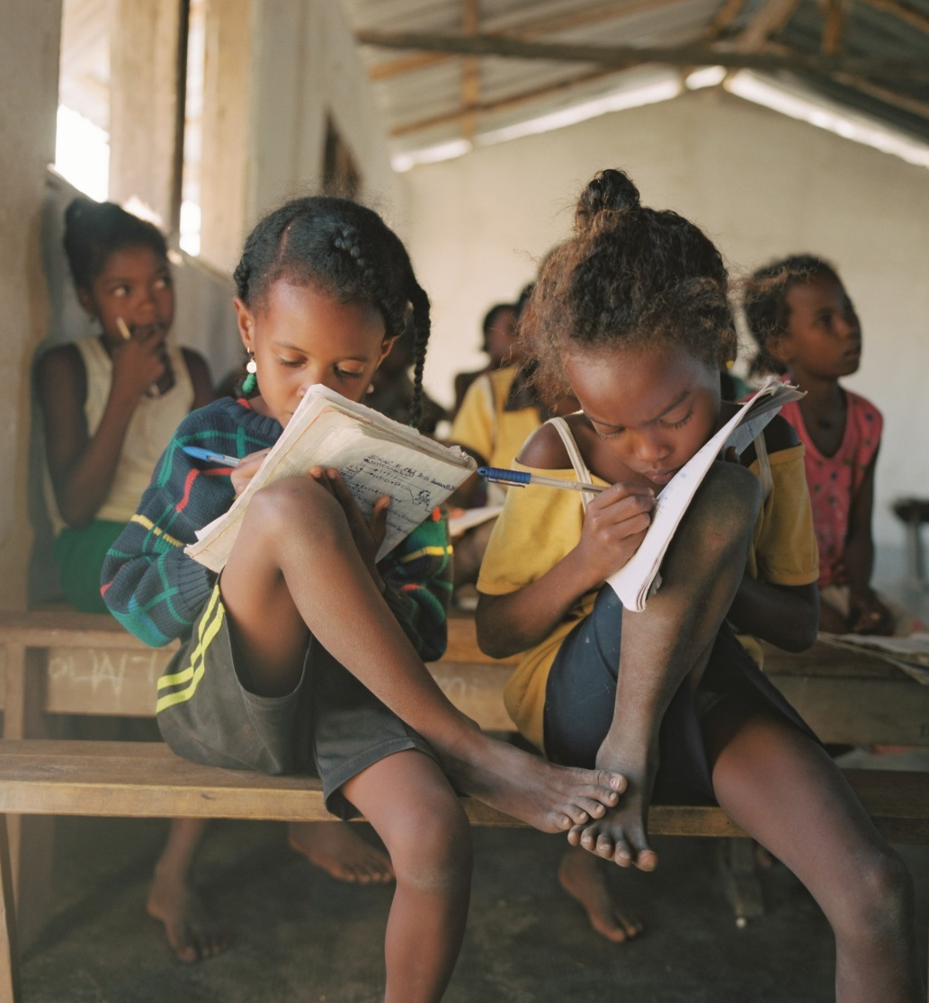
© Joan Bardeletti, Les Grands Moyens

CONTENTS

Project presentation 3
Challenges of African education systems 3
Objectives of the Education Fund 3
Spotlight: specificities of an impact fund 4
Implementation schedule 7

Presentation of the Strategic Council 8
The role of the Council 8
The members 8

Project Partners 10
The Government of Monaco 10
Investisseurs & Partenaires (I&P) 12
FERDI 15

PRESS CONTACTS

Emilie DEBLED – Director Exterior Relations and Development
+33 (0)1 58 18 57 11 | e.debled@ietp.com

Tom DILLY – Project Manager Education/International Volunteer of Monaco
t.dilly@ietp.com

Emilie LARESE-SILVESTRE – Programme Coordinator
+377 98 98 44 88 | esilvestre@gouv.mc

Project presentation

The Government of Monaco and Investisseurs & Partenaires have signed a partnership agreement to set up an impact investment fund by 2020 to address the issues of access, equity, quality and relevance of education, from pre-school education to higher education and vocational training, on the African continent.

Challenges of African education systems
African education systems face a number of common challenges. Although substantial investments to improve access to basic education have been made since the start of the millennium, universal basic education has not been achieved as 30 million children still do not attend primary school (UNESCO). The quality of education is still extremely low in African schools which are suffering from a “learning crisis”. In Côte d’Ivoire, over 60% of pupils lack basic skills in maths and reading at the beginning of primary school (PASEC 2014). The entire educational continuum is faced with issues of access, retention and relevance: pre-primary education is poorly developed in the majority of countries and regions, and retention and transition rates from basic education to secondary and higher education are low, especially for girls.

Growing demand for higher education and vocational training is driven by the demographic boom and an emerging middle class, but the lack of infrastructure and the gap between higher education training and the needs of the local job markets have increased youth unemployment and informal employment. Moreover, States and their partners have historically underinvested in vocational training programmes, which are still very poorly adapted to the needs of businesses. While 450 million jobs will be necessary to employ the workforce available in 2050, the imperative to match training programmes on offer with the needs of businesses will be a key challenge for African economies.

Although African governments have limited resources to resolve these issues, the private sector is increasingly perceived as a complementary player that could enhance access to, and the quality and relevance of education. Moreover, it is estimated that one child in five in Africa is educated in a private school (Caerus, 2017). However, to date contributions by the private sector are highly variable depending on the country and education cycle, and too few key players have emerged on the continent to attract potential funders and scale up. Few investment funds have focused their efforts on education, particularly in the impact investing sector.

Objectives of the Education Fund
The goals of the fund will be to address the challenges of access to, and the equity, quality and relevance of education in Africa by funding and supporting private educational institutions, and companies in the educational ecosystem producing goods, services and technology, which play a vital role in resolving these issues.

The fund will therefore contribute towards attaining Sustainable Development Goals n°4 “Ensure inclusive and equitable quality education and promote lifelong learning opportunities for all” and n°5 “Achieve gender equality and empower all women and girls”, defined by the United Nations and adopted by the international community.

Several impact goals will be defined to guide fund investments. A series of qualitative and quantitative indicators will be developed for each impact goal, and will enable the fund’s impact performance to be monitored on a regular basis.

1 | Increasing education and training opportunities, and more generally human capital training.
2 | Improving the quality of teaching and learning methods, as well as the attractiveness of local educational institutions
3 | Promoting equitable education through investment in fragile countries, or aimed at vulnerable populations
4 | Support for the education, integration and empowerment of girls and young women
5 | Strengthening the socio-economic integration of youth

Spotlight: specificities of an impact fund

The term “impact investing” was formalized in 2007 in an initiative led by the Rockefeller Foundation. In an initial effort to coordinate and standardise the sector, the Rockefeller Foundation established GIIN (Global Impact Investing Network) in 2009 which was largely focused on establishing a definition recognised and accepted by all: “Impact investments are defined as investments made into companies, organisations, and funds with the intention to generate social or environmental impact alongside a financial return. Impact investments can be made in both emerging and developed markets, and target a range of returns from below market to market rate, depending on investors' strategic goals.”

Unlike traditional investors, the impact investor sets an impact goal in addition to a financial goal. The intentionality of an impact investor is therefore characterised by his/her willingness to accept returns below market in order to generate extra-financial impact which is not taken into consideration by traditional investors.

To find out more:
- GIIN website
- Study by I&P and FERDI “Investing in Development in Africa: How Impact Investment can contribute to meeting the Sustainable Development Goals (SDGs) in Africa”

- Investment hypotheses
Several hypotheses are currently being tested as part of the feasibility study in process. These hypotheses concern the investment sectors and criteria (education cycles, types of educational institution, project maturity), as well as the geographical scope of intervention and the financial instruments to be deployed.

- Investment sectors
The fund may come into play in the higher education and vocational and technical training sector to foster the development of training institutes, technical colleges, higher education schools and universities with the aim of promoting the integration and employability of African youth. The impact fund could therefore support educational institutions in the construction and renovation of their infrastructure and amenities, in the structuring of their governance and management system, in the development of innovative educational tools, in the improvement and certification of their training programmes, in the integration of access and equity criteria when selecting and monitoring trainees, and in the socio-economic integration of their graduates.

The fund could also help to support teacher and educator training, as well as strengthening the capacity of schools in the basic education and pre-school cycle by supporting continuous training programmes and remote teacher training technologies and support mechanisms for schools and their managers.

- Geographical focus
The fund will be pan-African oriented and might be aimed at French speaking Africa where investment funds, in particular impact funds, are few, and where Investisseurs & Partenaires could be supported by its local network. It could also be deployed in some English speaking African countries depending on the opportunities and constraints of its model.

Spotlight: players involved in the sector

In 2018 I&P mapped out the financial players involved in the education sector in Africa: financial investors, strategic investors, Development Financing Institutions, multilateral organisations and foundations. Several key trends were observed:
- Impact investing strategies are still extremely rare
- Investments are made primarily in English speaking Africa, mainly South Africa and Kenya.
- The higher education segment is the most dynamic in terms of volume and number of transactions

Read more
• The business of Education in Africa, Caerus Capital
• Impact Investing in Education: An Overview of the Current Landscape, Open Society Foundations
• “Why the education sector urgently needs impact capital”, Maximpact Blog

- Financial Instruments
To support these educational institutions and other ancillary educational operators, the Fund could mobilise equity and quasi-equity investment instruments, as well as debt financing. It could also mobilise funding in the form of social component-based grants [Box below].

A hybrid financing project (blended finance)

Education is a social sector traditionally supported by grant programmes geared towards public or non-profit making organisations. Alongside an increasing number of initiatives in the emerging private education sector, some initiatives offer balanced, or even highly profitable, economic models while others are still immature and struggle to find financial equilibrium. The question of access is a key challenge for the booming private education sector, because too many quality educational institutions are currently targeted at wealthier populations only.

In order to address access and equity issues, the I&P Education Impact Fund could adopt a hybrid financing system (or blended finance) and be supported by a social component which could be deployed via a range of grants in the following areas :
- Training for high potential schools and companies in investment readiness thanks to specific support (mentoring, incubation, acceleration etc.)
- Maximisation of the Fund’s impact performance via technical assistance programmes in support of schools and companies involved, and provision of school grants or student loans to make training accessible to students from an underprivileged background.
- Appraisal of the Fund’s educational impact, in particular the quality of learning, thanks to field studies and long-term impact assessments.
- Advocacy to share experience about this innovative project and to promote the knock-on effects of impact investors in the African education sector

Implementation schedule

- September 2018 – May 2019: feasibility study
A feasibility study is currently being carried out and is designed to determine the opportunities and barriers relating to the creation of an impact vehicle dedicated to education within the African context. This study is being conducted by the Foundation for Studies and Research on International Development (FERDI) with the financial support of Monaco’s Cooperation. The study is targeted in particular at:
- Gaining a better understanding of African challenges in regard to education
- Identifying good practice in education that could be developed and disseminated more widely by the private sector
- Mapping out private investments in education in Africa
- Analysing the economic models of private operators in education.

- Summer 2019 – end 2020: setting up the team and raising funds
This research phase will begin in summer 2019 with the definition of the Fund’s investment strategy and impact and will also guide structuring opportunities (HR, legal, financial) and fundraising.
Hiring the investment and impact team, a fundraising phase and identifying the fund’s initial investments will follow until 2020. The aim is to complete the first round of fundraising in the second half of 2020.

- 2020-21: Initial investments
Once the fundraising phase is completed, the goal will be to begin investment activities in the education sector between late 2020 and 2021.

Presentation of the Strategic Council
The Strategic Council, set up in January 2019, brings together experts from the education sector, experts in the African context, and project ambassadors, and will guide its conduct until 2020.

The role of the Council

The Strategic Council will meet twice a year in 2019 and 2020, with a view to fulfilling the following objectives:
- Guiding, advising the team in charge of the project and steering its discussions, in particular with regard to defining the investment thesis and impact thesis.
- Ensuring the external coherence of the project, so that the fund provides a helpful response, complementary to public policy instruments implemented in the target countries
- Giving visibility to the project among networks dedicated to education in Africa

The members

The Strategic Council will be presided over and headed by Patrick Guillaumont.

Patrick Guillaumont is President of the Foundation for Studies and Research on International Development (FERDI), professor emeritus at the University of Auvergne, a researcher at the Centre d’Etudes et de Recherches sur le Développement International (CERDI), and Director of the Revue d’Economie du Développement.

Stéphanie Cohn Rupp
Former Director General of the Toniic Network and former consultant for the World Bank and UNESCO regarding educational issues in Sub-Saharan Africa, Mrs. Cohn Rupp is currently the Director General of the Tiedemann Wealth Management impact investment programme.

David de Ferranti
President of the R4D Foundation, an American think tank on Education and Health in the developing world. David de Ferranti is former Vice President and head of social programmes (Nutrition, Health, Education, Health Insurance) for the World Bank in Asia, Africa, Latin America and Eastern Europe.

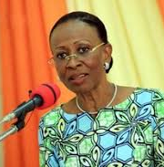 | Ramata Ly Bakayoko  Formerly the Republic of Côte d’Ivoire’s Minister of Higher Education and Scientific Research and President of the Félix-Houphouët-Boigny University in Cocody. Currently the Republic of Côte d’Ivoire’s Minister for Women, Family and Children’s Affairs.
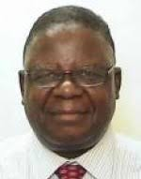 | Dzingai Mutumbuka  Dzingai Mutumbuka is the former Minister of Education of Zimbabwe and former senior executive at the World Bank in the human development sector. He is currently President of ADEA (Association for Education Development in Africa).
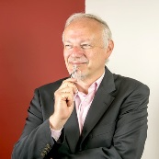 | Jean-Michel Severino  President of Investisseurs & Partenaires (I&P) since 2011, Jean-Michel Severino is dedicated to the new impact investing sector so as to promote the growth of small and medium-sized enterprises in Sub-Saharan Africa. Mr Severino was formerly Vice President for East Asia at the World Bank (1996-2000) and CEO of the French Development Agency (AFD) from 2001 to 2010.
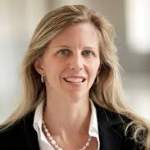 | Martina Viarengo  Martina Viarengo is an Associate Professor in the Department of International Economics at the Graduate Institute in Geneva. She is also faculty associate at the Harvard University, Center for International Development, and a member of the World Economic Forum’s Global Agenda Council on Women’s Empowerment.

Project Partners
The initial partnership for the design and formulation of the fund is comprised of the Government of Monaco as sponsor and funding body, Investisseurs & Partenaires (I&P) as operator and FERDI (Foundation for Studies and Research on International Development) as academic partner.

The Government of Monaco

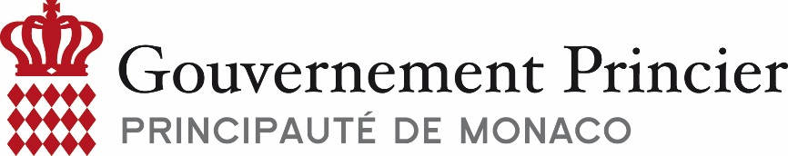

Website: https://cooperation-monaco.gouv.mc/en

The Government of Monaco implements its cooperation policy through its Office of International Cooperation (DCI) attached to the Ministry of External Relations and Cooperation.

Its priority intervention area is the fight against poverty in connection with the United National Sustainable Development Goals, primarily those focused on the human being. Monegasque Official Development Assistance is distributed in the form of donations and technical assistance, and represents slightly over 1% of the government’s revenue. This assistance helps to support over 130 projects each year in eleven partner countries, with special focus on the most disadvantaged:
- The Least Developed Countries (LDCs): Mali, Mauritania, Niger, Burkina Faso, Madagascar, Senegal and Burundi;
- Middle-income developing countries: Morocco, Lebanon, Tunisia and South Africa.

4 areas of intervention are given preference, in accordance with the national policies of the countries concerned: health, food security, socio-economic integration and education.

6 multi-country and multi-partner flagship programmes are also given priority to strengthen the impact and visibility of Monegasque assistance: the fight against malaria, the fight against sickle cell disease, support for vulnerable children, support for civil protection, child nutrition and job creation.

The most vulnerable populations form the core target of government action and concern more specifically children, women, the disabled and refugees.

In the field of education, the Government of Monaco invests on the African continent and in the Middle East to educate youth, from pre-school education to vocational integration, primarily in countries where the average number of years of schooling is the lowest in the world (Sahel) and where there is massive youth unemployment (Mediterranean). Vulnerable children and youth (street children, orphans, disabled, refugees…) are specifically targeted and special attention is paid to girls’ education (SDG n° 4, 5, 8 and 10). Monaco cooperates in this field with public authorities, local and international civil society and multilateral partners. The Principality is also committed to joining forces with the private sector, especially players from the Social and Solidarity Economy and impact investing, in order to address these challenges, in the same way as this innovative partnership is doing.

Over the 2015-2017 period, Monaco action facilitated the learning paths of over 50,000 children, the majority of whom were in primary and secondary education, 8,000 in pre-school education and 7,000 in vocational training. Ongoing operations supported by Monaco include: support for the education of disabled children in Maghreb and refugee children in Lebanon, support for entrepreneurship for rural youth in the Sahel, support for new skills training (e.g. occupational therapy in Morocco).

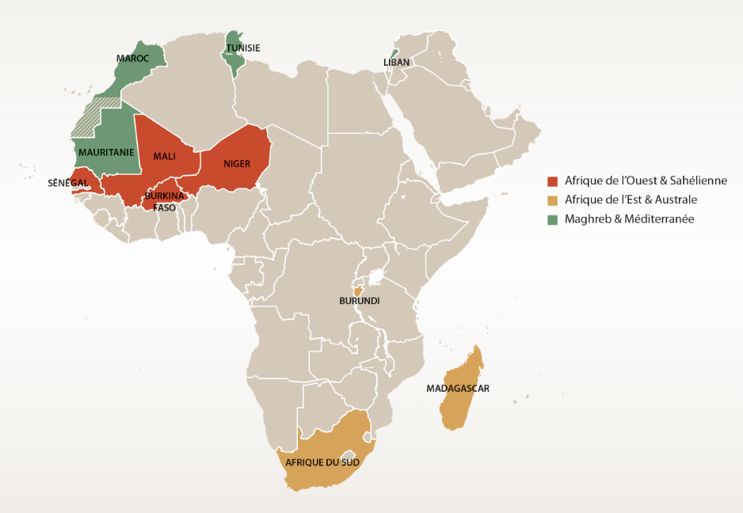
Priority partner countries of the Monegasque Cooperation

Investisseurs & Partenaires (I&P)

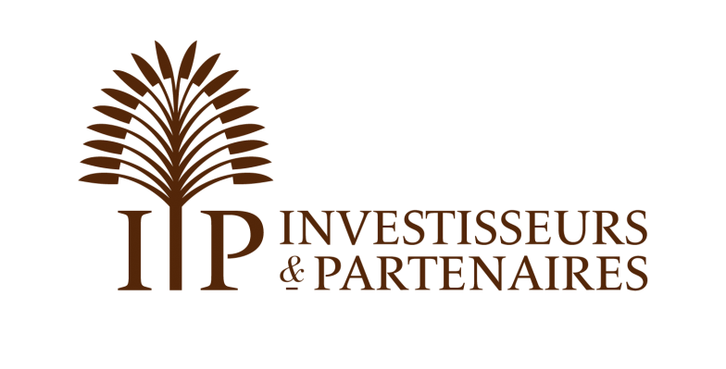
Website: http://www.ietp.com/en

Investisseurs & Partenaires (I&P) is an impact investment group dedicated to small and medium-sized enterprises in Sub-Saharan Africa, key players in sustainable and inclusive growth on the continent.

Since it was established in 2002, I&P has funded over 90 businesses based in 16 African countries, chiefly in French-speaking Africa, from Madagascar to Senegal. These businesses create local value and sustainable jobs, but also have a significant social, environmental and governance impact.

I&P is an active partner which, in addition to financial investment, provides expertise in strategy, finance and management to foster the growth of its partner companies. I&P manages four impact funds - IPDEV1, IPDEV2, IPAE1 and IPAE2 – which represent 136 million Euros of managed assets in total. These funds are differentiated by the company size they target.

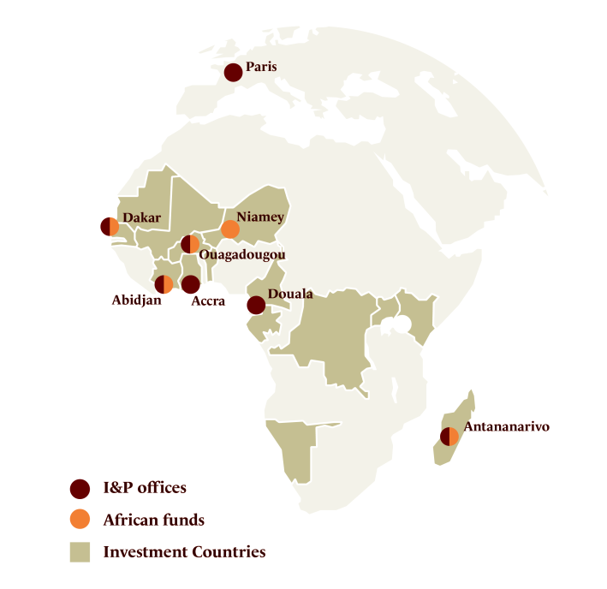
Founded by Patrice Hoppenot in 2002 and headed by Jean-Michel Severino since 2011, Investisseurs & Partenaires employs about 50 people based in Paris and seven African offices (Burkina Faso, Cameroon, Ghana, Côte d’Ivoire, Madagascar, Niger and Senegal).

I&P’s experience in the education sector
Thanks to its investment activity, I&P teams have acquired unprecedented experience in the education sector in Africa, particularly in vocational training (Trainis), higher secondary education (Enko Education), higher technical and vocational training (IST, CAIF), educational facilities and materials (Editions Afrique Lecture, Unifam, Valesse) as well as the implementation of specialised investment vehicles in the sector (Comoé Education Impact Fund), in several West African countries but also the rest of the continent.

Jean-Michel Severino has gained thirty years’ experience of educational issues in Africa, while working within the Ministry of Cooperation, the World Bank, and subsequently as Director General of the French Development Agency between 2001 and 2010. He is pursuing this commitment at the head of I&P and currently sits on the board of the UNESCO Institute.

A few examples of investment in the education sector
AFRICAN MANAGEMENT INITIATIVE

Country  Entrepreneurs  Fund  In the portfolio since | Kenya  Jonathan Cook, Rebecca Harrison  IPAE 2  2018

Launched in 2014, African Management Initiative (AMI) provides pioneer vocational training geared towards African managers and entrepreneurs.
AMI has developed 45 practical business modules – including over 2,000 tools – with Africa’s leading business schools and global experts on adult learning. AMI’s training programmes are based on a blended offer of both online material and face-to-face workshops with experts in their field.

IMPACT GOALS
• Bringing quality education to middle management of African companies
• Delivering employability and entrepreneurship training programmes to youth, women and a larger number of small-scale entrepreneurs.

CENTRE D’APPUI À L’INITIATIVE FÉMININE

Country  Entrepreneurs  Fund  In the portfolio since | Senegal  Arame Dramé, Insa Dramé  Teranga Capital  2018

The Centre d'Appui à l'Initiative Féminine (CAIF) is a vocational training centre specialising in careers in the hospitality industry, dressmaking, fashion design, hairdressing and beauty.
Created 14 years ago, CAIF has developed a strong expertise to offer its trainees, mainly young Senegalese women, high quality training adapted to the job market.

IMPACT GOALS
• Affordable vocational training leading to a diploma for a young target group excluded from the traditional school system
• Integration of graduates into the professional world
ENKO EDUCATION

Country  Entrepreneurs  Fund  In the portfolio since | Pan-African  Cyrille Nkontchou, Eric Pignot  IPAE 1  2016

Enko Education aims to build one of the largest African networks of private schools in Sub-Saharan Africa, with a strong emphasis on French-speaking countries.
Enko provides a renowned and high quality education with a view to facilitating entry to international universities. Enko has formed partnerships with existing secondary schools to develop a 3-year programme with International Baccalaureate (IB) accreditation, widely recognised by international universities.

IMPACT GOALS
• Develop a network of 30 schools, with over 10,000 students every year
• Access to international universities
• Dozens of teachers trained to international standards

FERDI

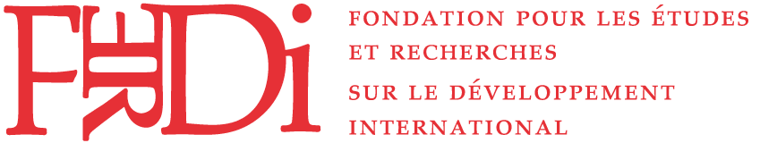

Website: http://www.ferdi.fr/en

The Foundation for Studies and Research on International Development (FERDI) is a think tank whose primary mission is to influence international debate on key development issues.

Created in 2003, FERDI is a non-profit and independent foundation. It mobilizes high-level economists and offers innovative thinking on key issues in the field of international development economy. It is particularly active on issues related to development efficiency, sustainable development and global governance.

FERDI is based in Clermont-Ferrand and has offices in Paris, in Ouagadougou and Washington D.C. Patrick Guillaumont is the founder and President of FERDI.

Missions
- Promote research excellence, with a particular focus on French-speaking and European research
- Combine reflection and decision
- Strengthen the capacity of developing countries to design and implement inclusive and sustainable economic policies

FERDI's contribution to the project
FERDI has published several papers focusing on education from different perspectives (health, agenda 2030, demographic data, etc.) and brings its research capacity to the project. With the financial support of the Government of Monaco, FERDI is conducting the feasibility study following four key objectives: 1/ Obtain a better understanding of African educational challenges, 2/ Identify good educational practices that can be developed and disseminated more widely by the private sector, 3/ Realize a state of private investment in education in Africa, 4/ Analyze the economic models of private operators in education

Recent publications in the field of education
- Can social groups impact schooling decisions? Evidence from castes in rural Senegal (2018) Ababacar S. Gueye (CERDI-UCA, CNRS), Martine Audibert (CERDI-UCA, CNRS, Ferdi), M., Valery Delaunay (LPED, IRD). World Development, vol. 110, October 2018, pp. 307-323
- The Geography of Talent: Development Implications and Long-Run Prospects (2018), Michal Burzynski (CREA, University of Luxembourg), Christoph Deuster (IRES, Universite Catholique de Louvain), Frédéric Docquier (IRES, Université Catholique de Louvain, Ferdi), FERDI Working paper P221, March
- Optimal Education Policy and Human Capital Accumulation in the Context of Brain Drain (2018), Slobodan Djajić (Graduate Institute), Frédéric Docquier (IRES, Université Catholique de Louvain, Ferdi)., Michael S.Michael (University of Cyprus), FERDI Working paper P224, March
- Impacts démographiques des crises africaines : une perspective historique (2017), Michel Garenne (Institut Pasteur, Ferdi), FERDI, Document de de travail P196, juillet
- Macroeconomic Crisis, Primary Education and Aid Effectiveness (2017), Rohen d'Aiglepierre (AFD), Laurent Wagner (Ferdi), AFD Research Paper 37
- Trois jalons pour la mise en œuvre de l’agenda 2030 en éducation (2016), Christophe Deconinck (expert en politique éducative) Ferdi Note brève B166, décembre
- Malaria and Education: Evidence from Mali (2017) Josselin Thuilliez (CNRS, Centre d'économie de la Sorbonne, Ferdi), Hippolyte d'Albis (Paris School of Economics—CNRS ), Hamidou Niangaly (University of Bamako), Ogobara Doumbo (University of Bamako), Journal of African Economies, Volume 26, Issue 4, 1 August 2017, Pages 443–469.
- Natural disasters, migration and education: an empirical analysis in developing countries (2015), Alassane Drabo (Ferdi), Linguère Mously Mbaye (African Development Bank Group) , Environment and Development Economics, Vol. 20 (06) December 2015, pp 767-796.
- Large-scale health interventions and education: Evidence from Roll Back Malaria in Africa (2015) Maria Kuecken (Centre d'économie de la Sorbonne, Paris School of Economics), Josselin Thuilliez (CNRS, Centre d'économie de la Sorbonne, Ferdi), Marie-Anne Valfort, (Centre d'économie de la Sorbonne, Paris School of Economics), Documents de travail du Centre d'Economie de la Sorbonne 13075r, Université Panthéon-Sorbonne (Paris 1), Centre d'Economie de la Sorbonne.

Database related to education:
- HAI – Human Assets Index -(updated in 2016)
- Demographic trend: Education in Sub-Saharan Africa (updated in 2015)

